PRESIDENTS’ ADDRESS AND OPTICAL QUESTION TIME AT OPTRAFAIR 20/20
Optrafair 20/20 offers world class presentations and debate from industry experts covering the issues and concerns facing the optical industry, as well as providing suggested solutions. The Presidents’ Address and Optical Question Time are exclusive, brand-new features at a revitalised Optrafair 20/20, which offers delegates a unique opportunity to hear from the Presidents of some of the county’s leading colleges, industry and membership bodies, retailers and practitioners from independent practices and corporates. Register free to join these sessions.
The Presidents’ Address will be chaired by Clive Marchant, ABDO’s President, and features Mike Burdon, President of the Royal College of Ophthalmologists. Colin Davidson, Vice President of the College of Optometrists, Richard Whittington, Chief Operating Officer at LOCSU and Jonathon Bench, President of BCLA. The theme for the Presidents’ Address will be ‘What are the main priorities for the profession in improving eyecare for the public?’
Optical Question Time is another new feature for Optrafair 20/20, with high-profile entrepreneurs, practitioners and experts from across the optical sectors. The panellists taking part include Doug Perkins, co-founder of Specsavers, David Moulsdale, Chair and CEO, Optical Express and Imran Hakim, Chief Executive, Hakim Group, as well as Lynne Fernandes, Lynne Fernandes Optometrists, Professor Nicholas Rumney, Chair, BBR Optometry Ltd and Dr. Scott Mackie, Co-Founder, Mackie Eyecare and Director, Mackie Professional Services.
We are also delighted to announce that Optician comedienne Sarah Morgan will host proceedings.
Optical Question Time Themes will be:
- NHS
- Education
- Environment
- The Market Place
- The Future
There will be an opportunity to ask questions at the end of the session.
Chair of FMO, Stuart Burn said: ‘Gaining the support and commitment of so many of the country’s leading experts and industry leaders for the Presidents’ Address and Optical Question Time, will provide a fantastic forum to discuss and debate the issues that really matter to the industry. Feedback from last year’s Optrafair revealed a demand for top level debate. I can assure you that Optrafair 20/20 will be well worth the wait.’

‘Both the Presidents’ Address and Optical Question Time will offer frank and insightful discussion and debate. Optrafair 20/20 will offer delegates the opportunity to glimpse into the future of practice and provide practitioners with some valuable thoughts on their future strategy.
Optrafair 20/20 will take place between April 4 and 6 at the NEC in Birmingham. Find more information here, and register your free place here.

GRAPHICS:
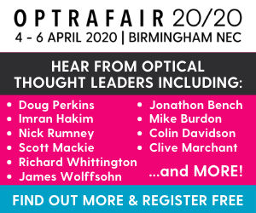

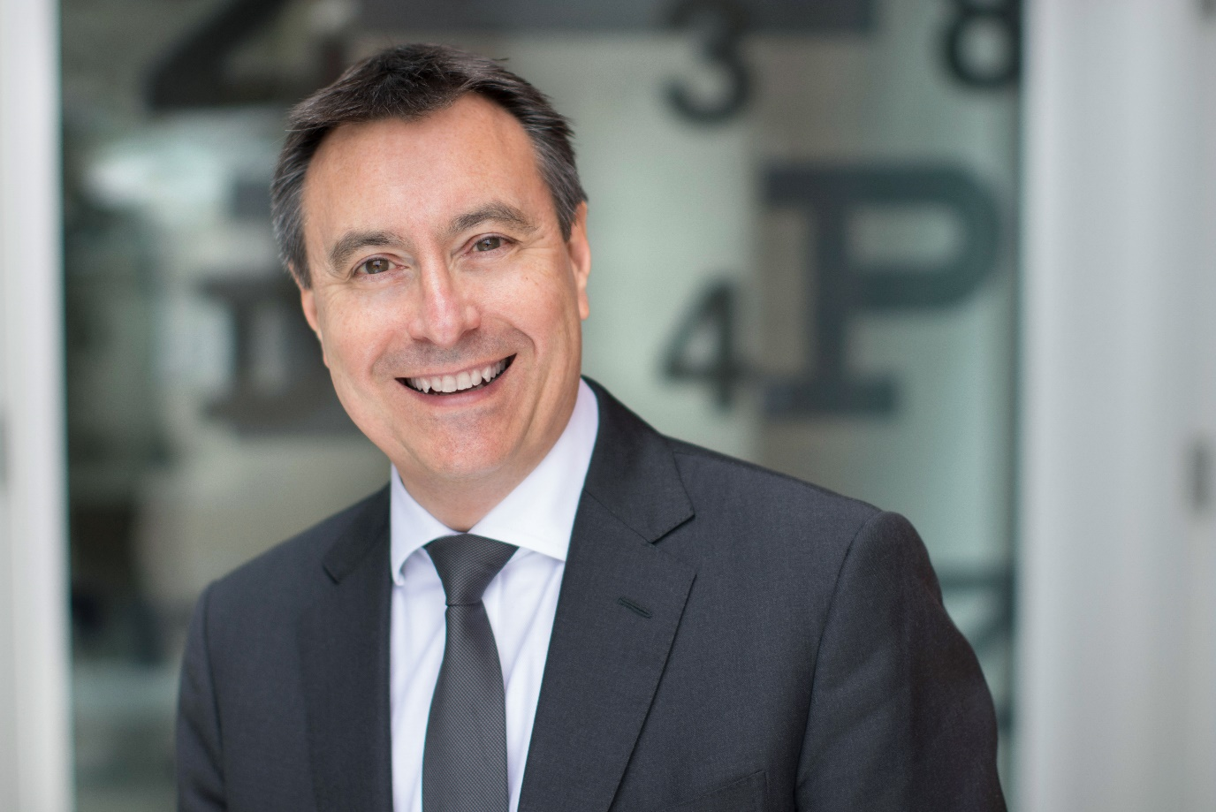
1 Lyndon Jones
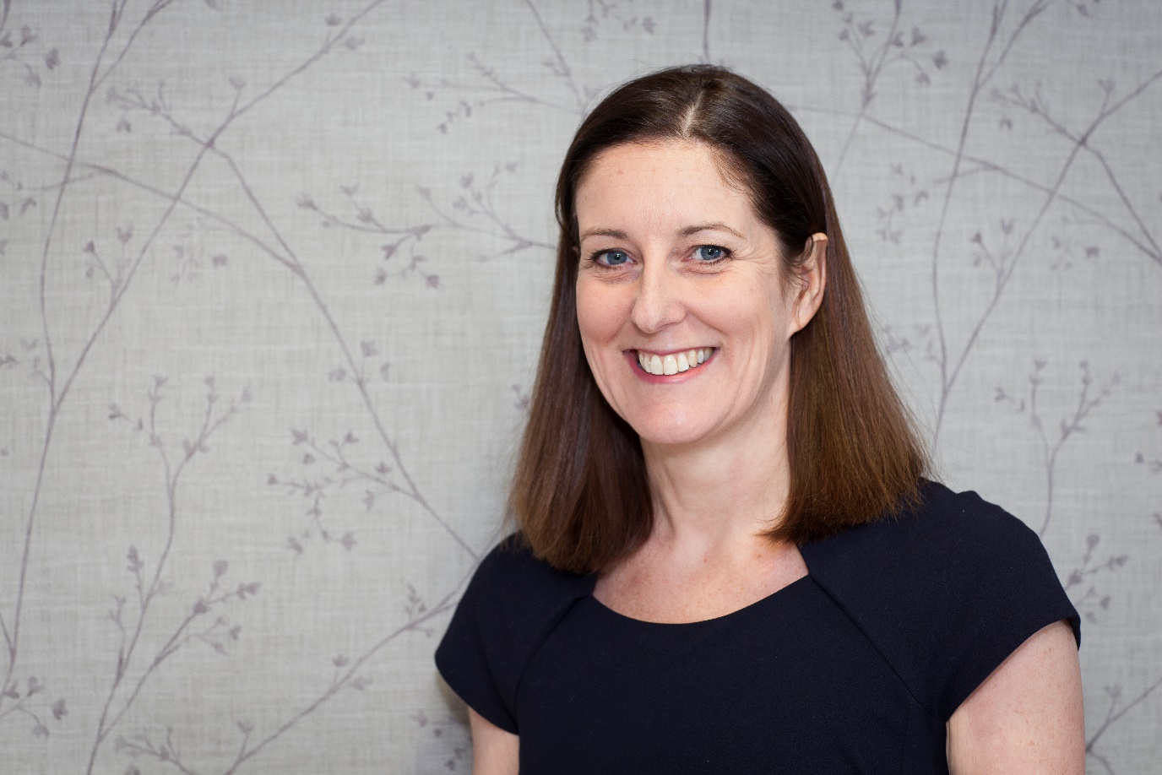
2 Lynne Fernandes
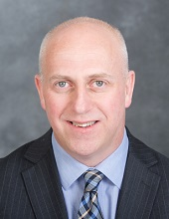
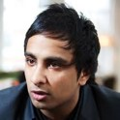
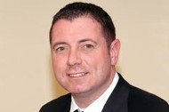
3 Scott Mackie
4 Imran Hakim
5 David Moulsdale
6 Mike Burdon
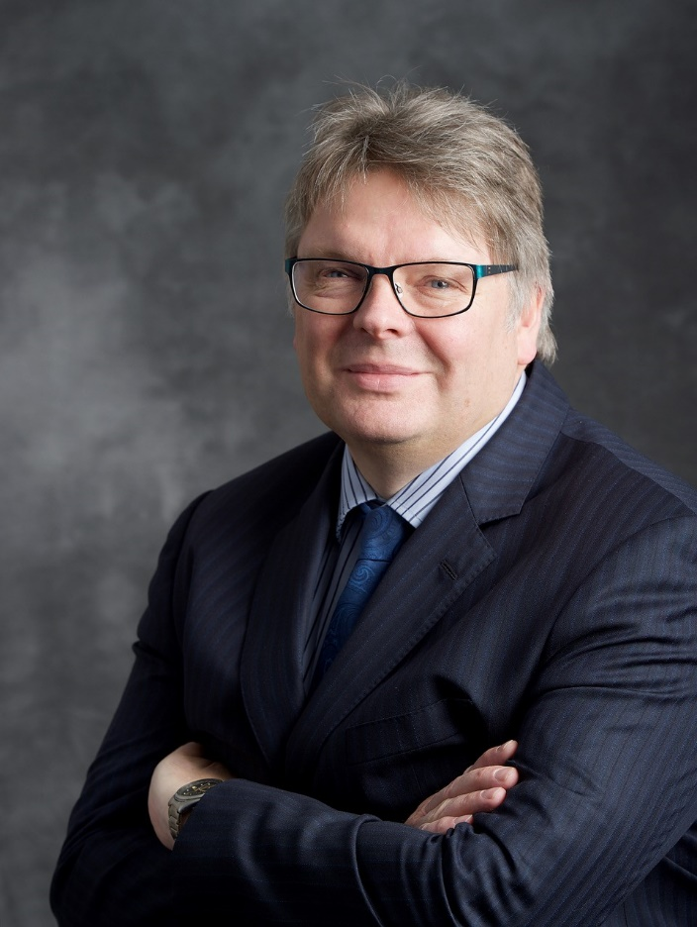
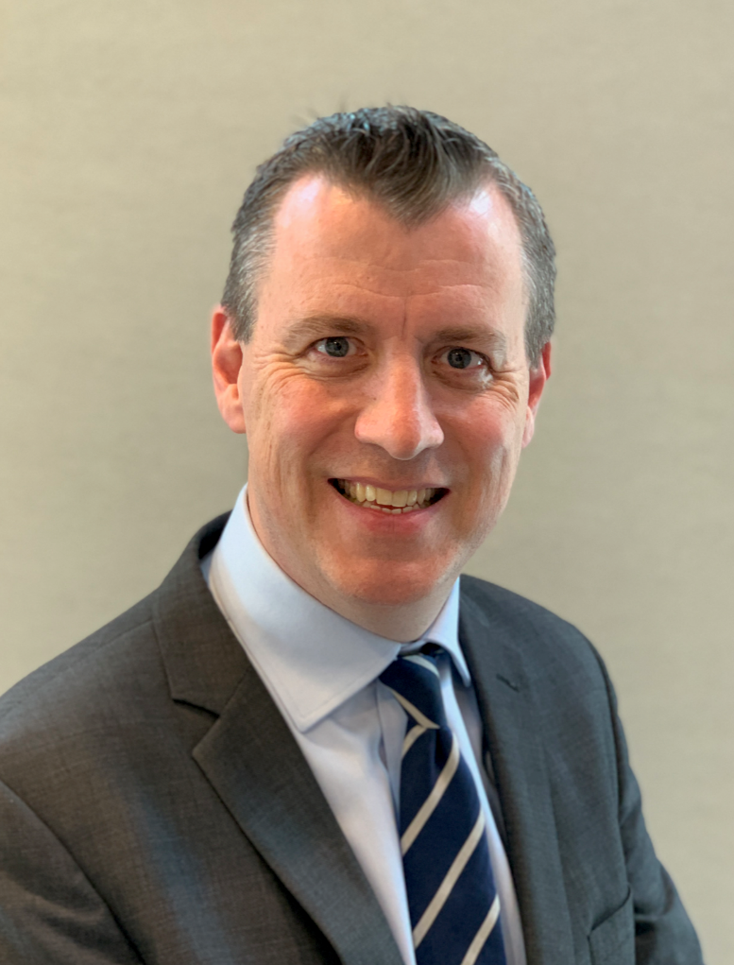
7 Nick Rumney
8 Philip Morgan
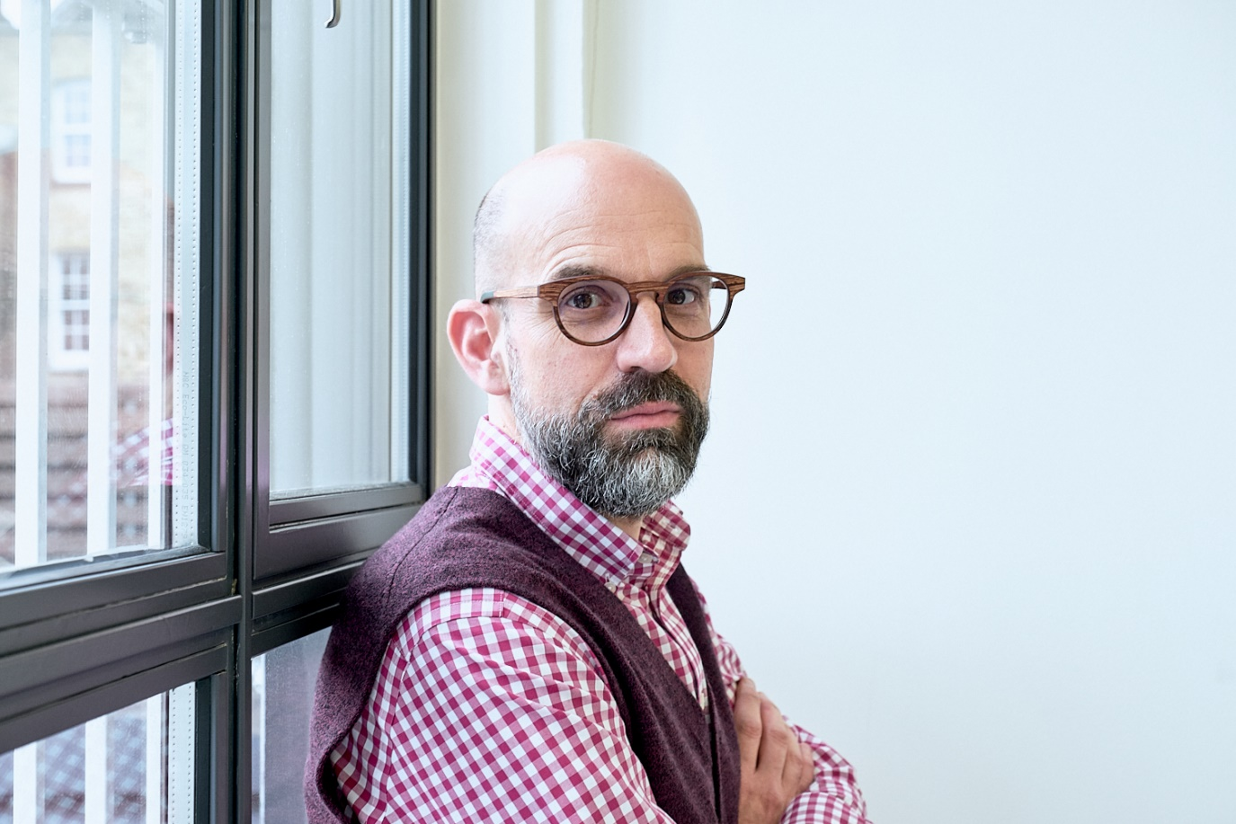
9 Richard Whittington
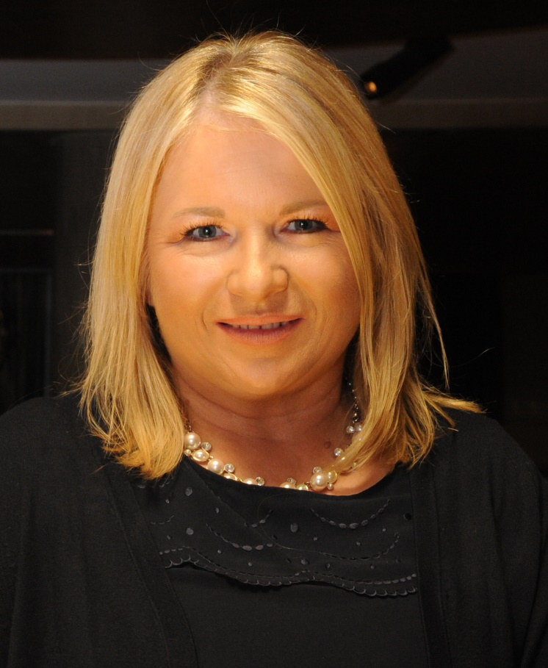
10 Sarah Morgan

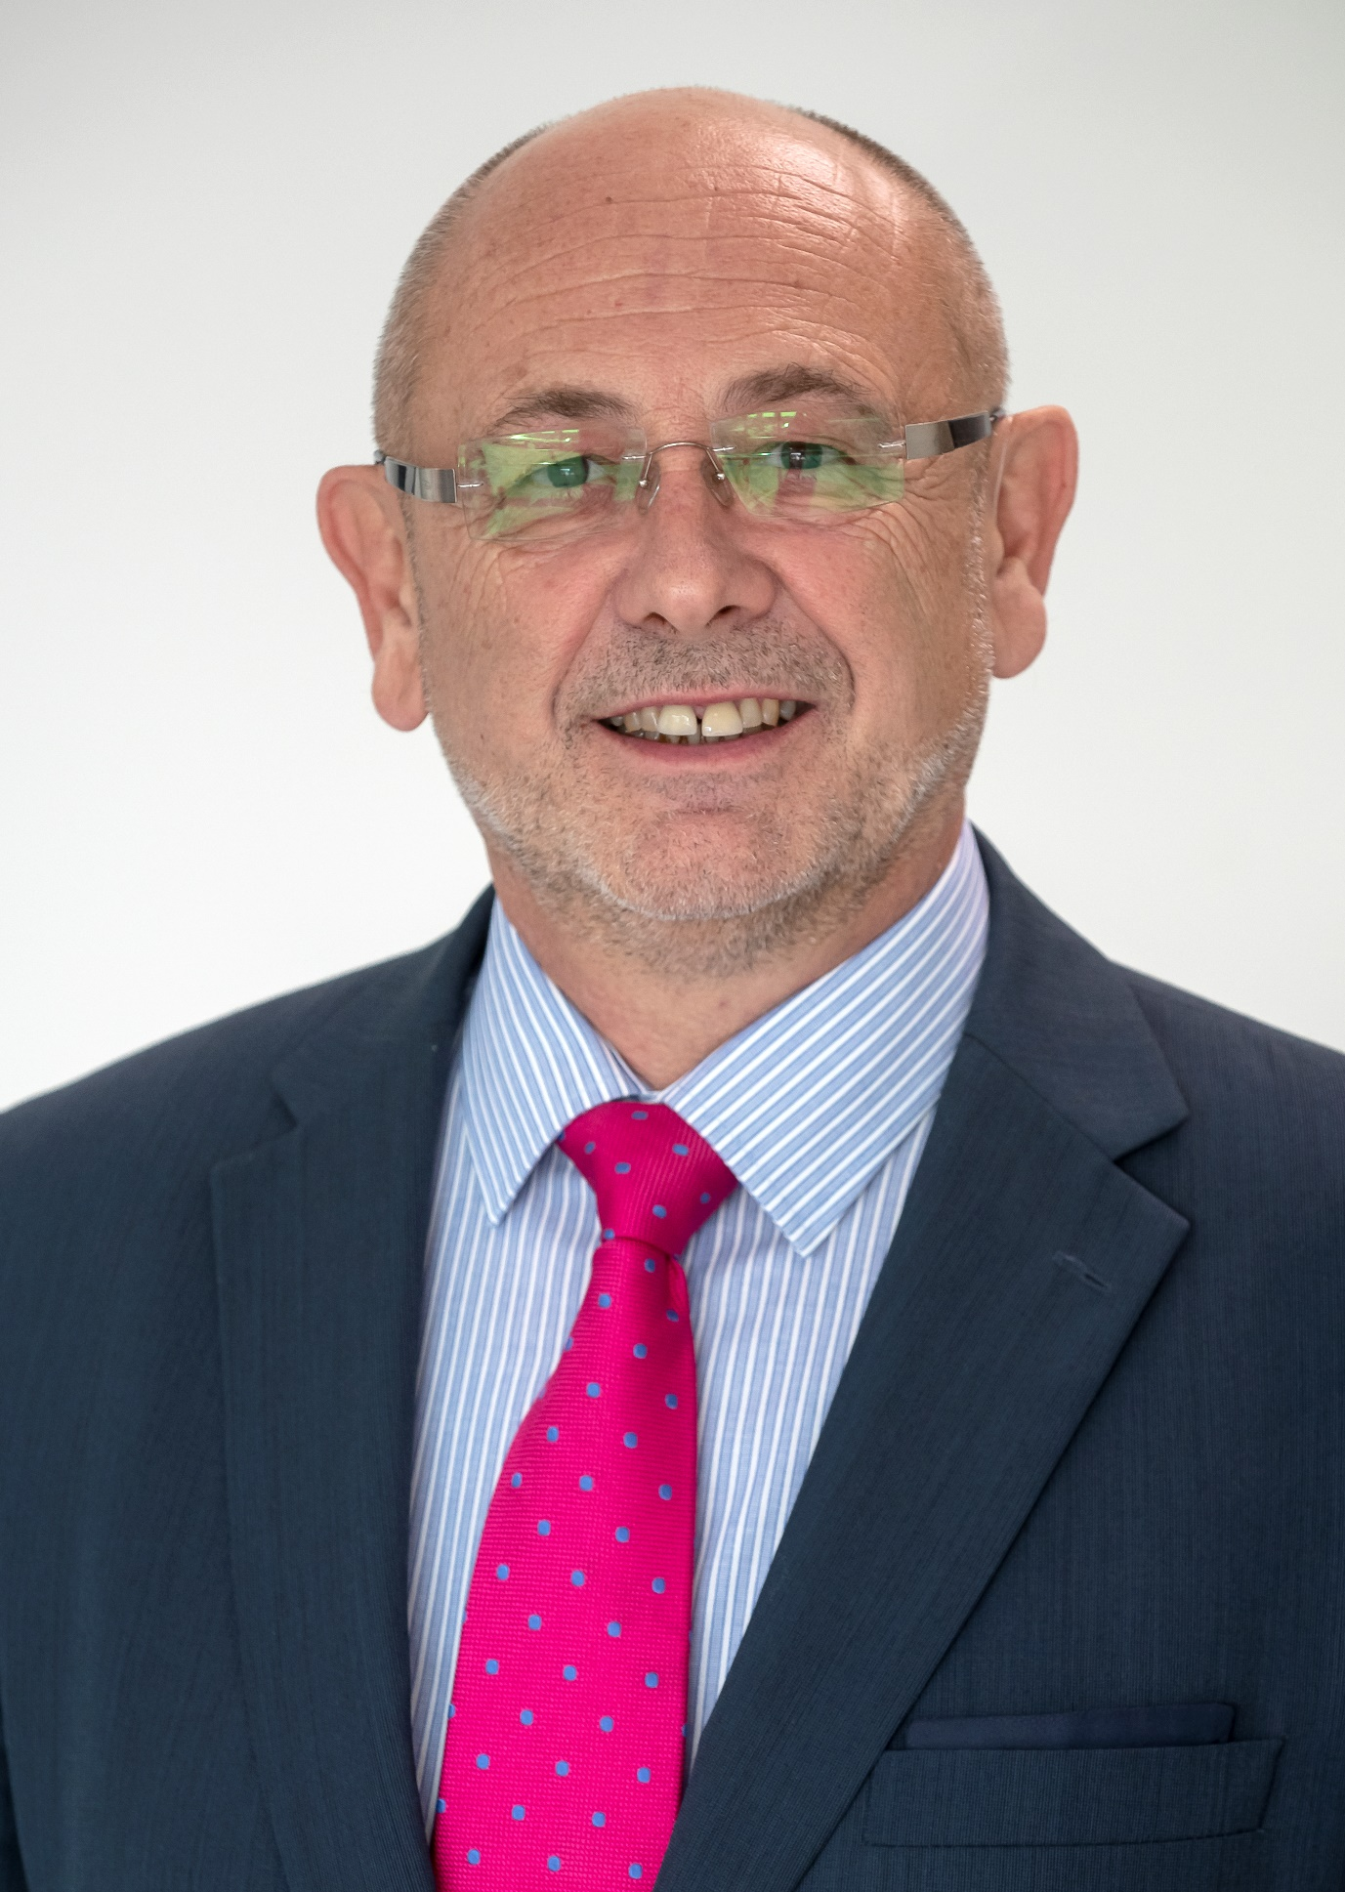
11 Clive Marchant
12 Colin Davidson
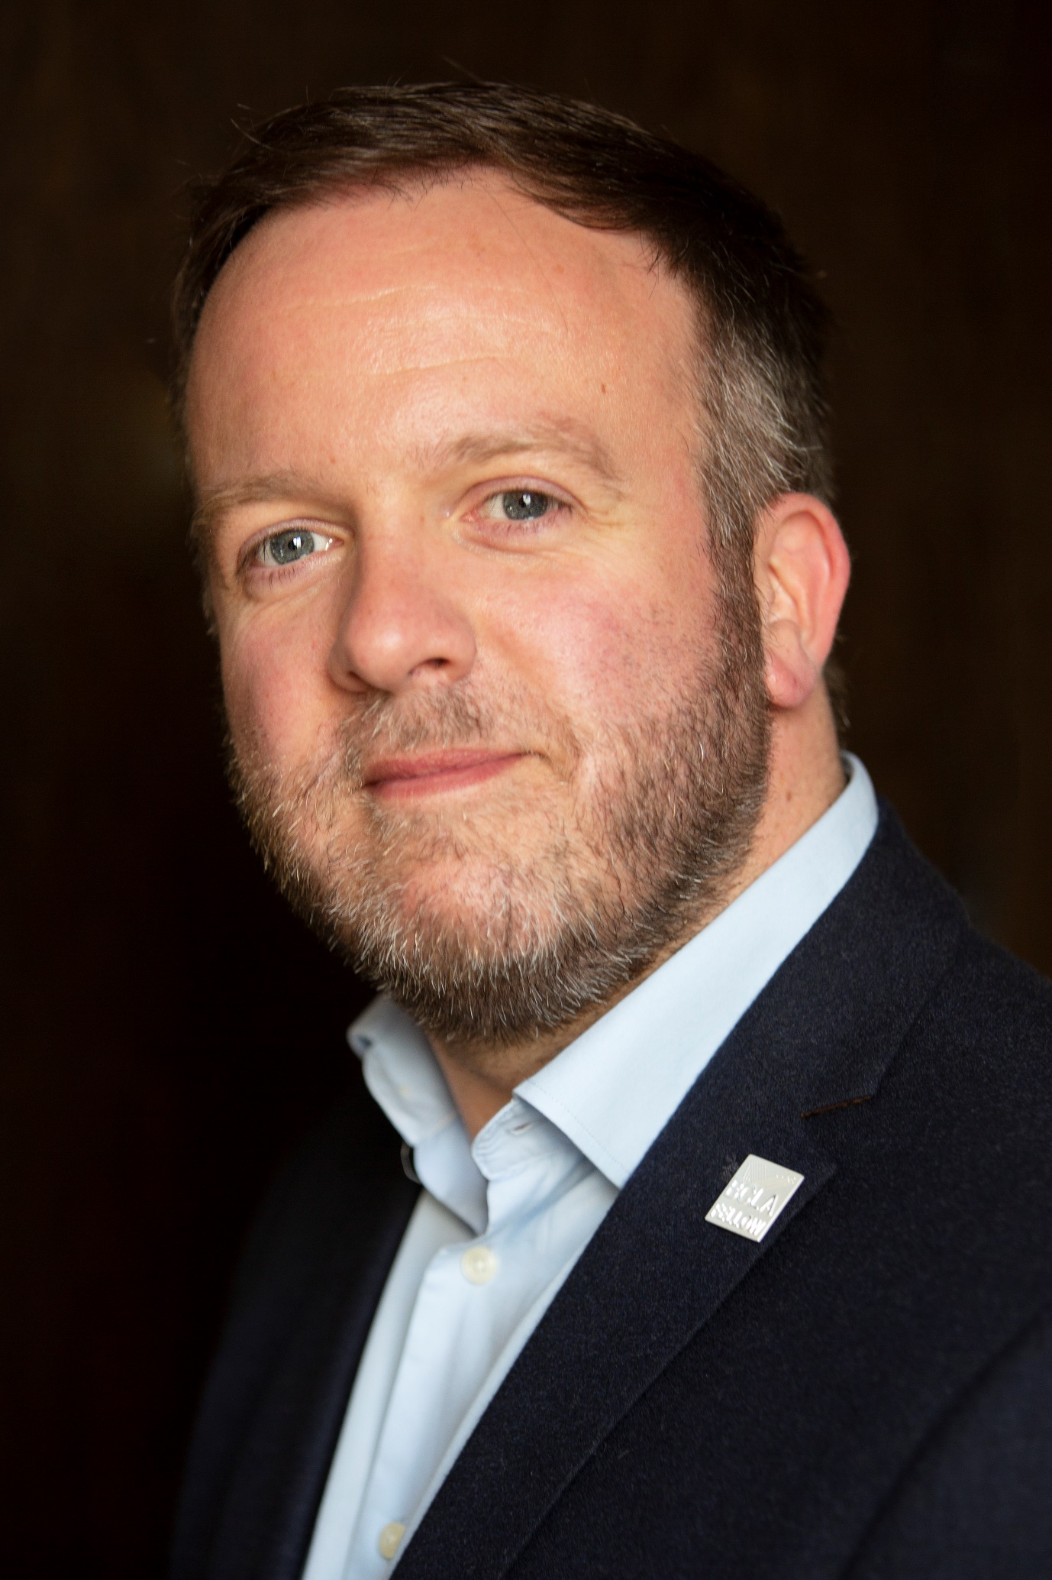
13 Jonathon Bench

